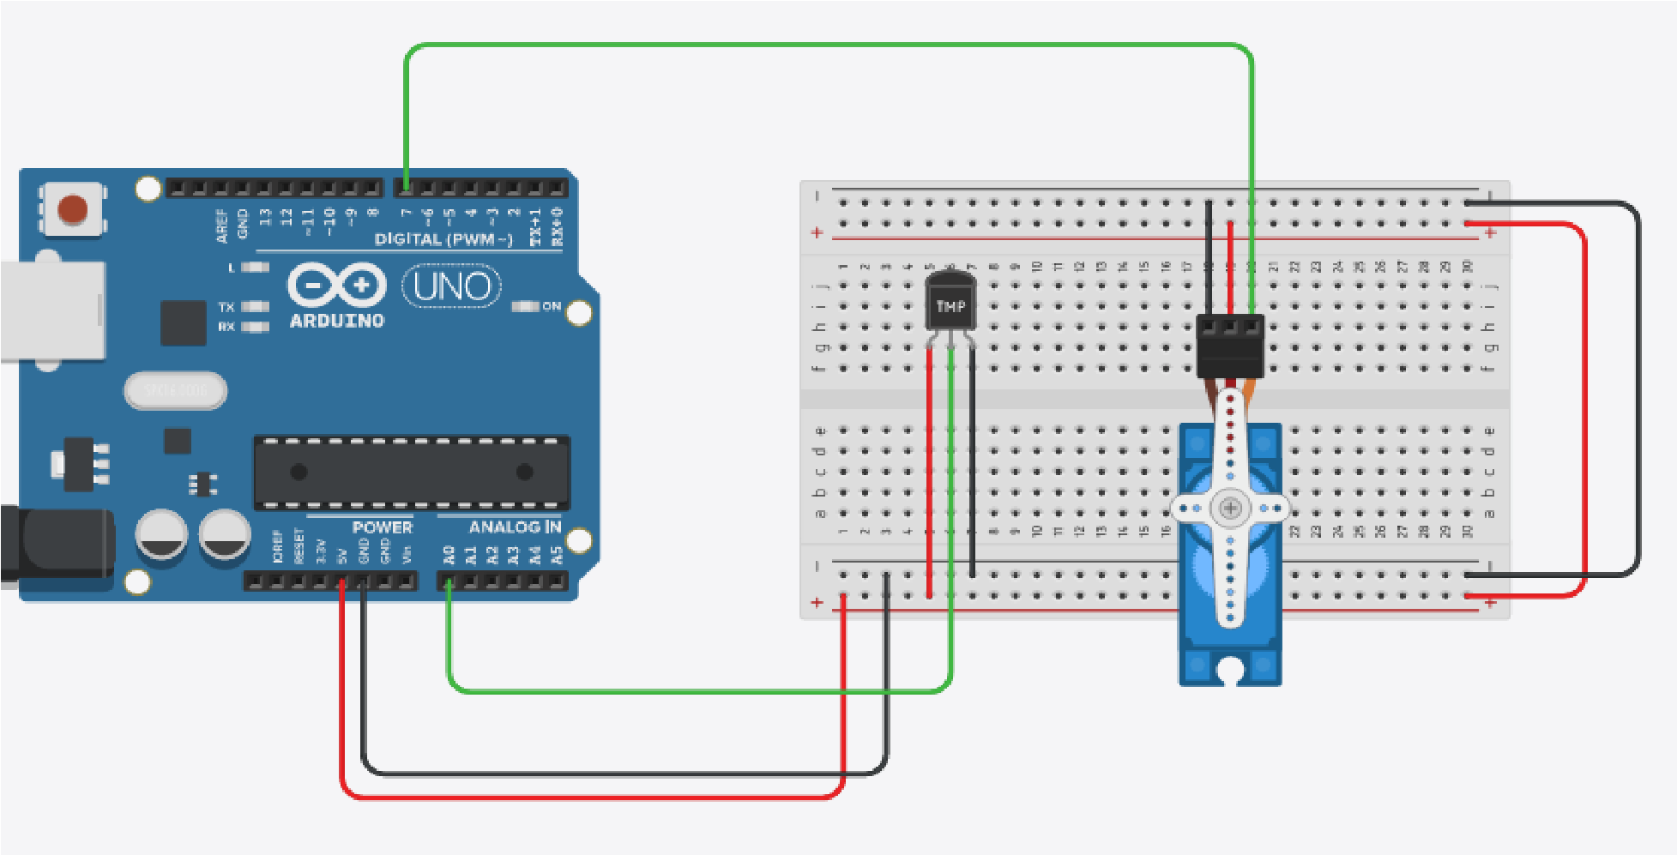

#include <Servo.h>

C++ code

int sensor_input; float temp; Servo myServo;

void setup()

{

Serial.begin(9600);

myServo.attach(7);

}

void loop()

{

temperature();

servo();

}

void temperature()

{

sensor_input = analogRead(A0);

int c = map(((sensor_input - 20) * 3.04), 0, 1023, -40,

125 );

Serial.print(c);

Serial.print(" Celsius "); int f = ((c * 9 ) / 5 + 32);

Serial.print(f);

Serial.println(" Fahrenheit");

// temp = (float)sensor_input / 1024;

// temp = temp * 5;

// temp = temp - 0.5;

// temp = temp * 100;

// Serial.print(temp);

// Serial.println(" Celsius");

}

void servo()

{

myServo.write(0); delay(500); myServo.write(90); delay(500); myServo.write(180); delay(500); myServo.write(360); delay(500);

}